Unit 3: Activity 2

1.
(a) pseudocode

Get a bowl
Get a spoon
If we have milk
Get milk
Otherwise
Get milk at store
If we have cereal
Get cereal
Otherwise
Get cereal at store
Add cereal to bowl
Add milk to bowl

(b) UML activity diagram
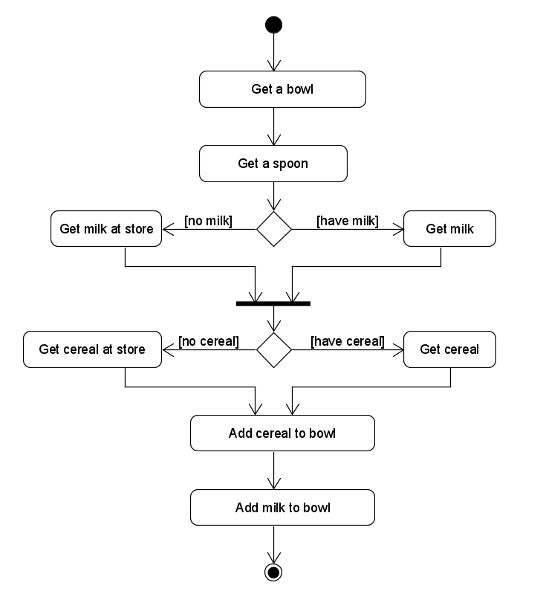

2. Make trip to the store only once to get milk or/and cereal

UML activity diagram

